Ideation Phase
Empathize & Discover

Date | 25 September 2026
Team ID | SWTID-2026-4039
Project Name | AI Weather Wise
Maximum Marks | 4 Marks

Empathy Map Canvas:
An empathy map is a simple visual tool used to understand how users think, feel, and respond to weather-related information.
For the AI Weather Wise project, it helps the team understand users’ needs, expectations, and difficulties when checking weather conditions. It allows us to look at the weather problem from the user’s point of view and identify what information they need for planning their daily activities. This helps the team create a useful and user-friendly weather prediction solution.
Example:
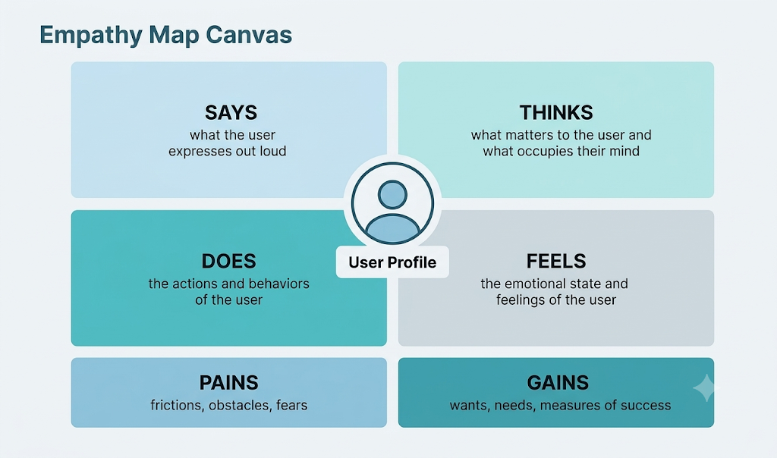

Example: Food Ordering & Delivery Application

